Satter, E. (1986) The feeding relationship.

Division of Responsibility in Eating:

Parent chooses what to offer (safe and appropriate foods), and offers it in a positive fashion

Child chooses how much or whether they eat.

Children who are consistently frustrated around feedings begin to associate hunger with anxiety

As adrenalin increases, appetite decreases

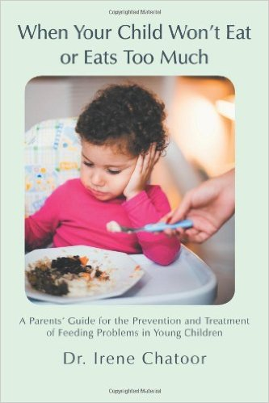
Chatoor, I. (2012) When your child won’t eat or eats too much.

Help Your Child to Recognize Hunger and Feeling Full

Establish a meal schedule

3 meals, 2 snacks

Only water in between meals

Limit meals to 20-30 minutes

Parents offer developmentally appropriate foods in a positive or neutral manner

Offer 3-4 foods per meal, including 1 food the child will be successful in eating

Children are seated upright with family members

Children receive positive social support during mealtimes

Adults are engaging but not overwhelming, speaking in a calm and encouraging manner

Children are allowed to self-feed with parents present but not intervening

Children are allowed to decide when they are finished eating

