WITH SPECIAL ATTENTION TO YOUNG CHILDREN WITH ASD, VISION IMPAIRMENT AND OTHER DISABILITIES

BOOKS
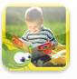 | I like Books (1.99) | 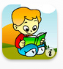 | Story Time for Kids (free)

COLORING AND DRAWING
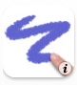 | I like Books (1.99) | 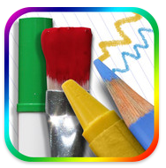 | Story Time for Kids (free)
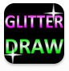 | Glitter Draw (1.99) | 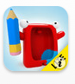 | Drawing with Carl (free)
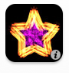 | Glow Coloring (free) | 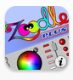 | Zoodle Pad (free)
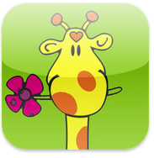 | Kid Art (.99)

MUSIC
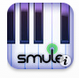 | Magic Piano (free) | 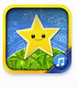 | Toddler Jukebox (1.99)

SIMPLE CAUSE AND EFFECT
 | Tap Tap Baby (1.99) | 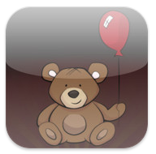 | Tap-n-See Zoo (2.99)

COMMUNICATION (AAC)
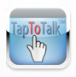 | Tap to Talk (free) |  | Look2Learn(14.99)
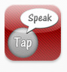 | Tap Speak (49.99) | 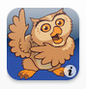 | ProLoquo2Go (189.99)
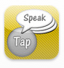 | Tap Speak Sequence (29.99) | 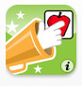 | Sounding Board (49.99)
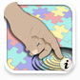 | iConverse (9.99) | 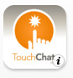 | TouchChat HD (149.99)
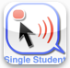 | iClick I Talk (19.99) | 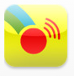 | Scene and Heard (49.99)

SOCIAL DEVELOPMENT
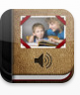 | Pictello (18.99) | 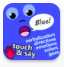 | Touch and Say-Emotions (free)
 | Stories2Learn (13.99) | 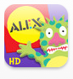 | Moody Monster Manor (free)

VISUAL SCHEDULES
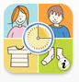 | iPrompts (49.99) |  | iCommunicate (49.99)
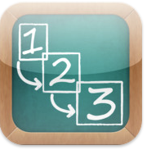 | First Then Visual Schedules (9.99) | 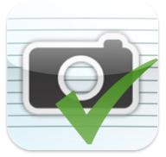 | Picture Scheduler (2.99)
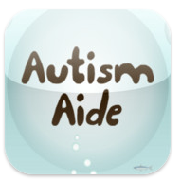 | AA Visual Schedules (9.99) | 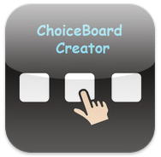 | Choice Board Creator
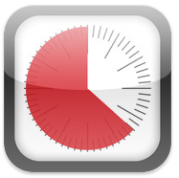 | Time Timer (6.99) |  | My Choice Board (9.99)

VISION
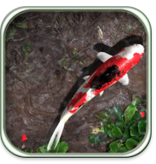 | Pocket Pond (free) | 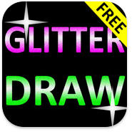 | Glitter Draw (free)
 | Sparkabilities Babies 1 HD (4.99) | 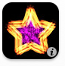 | Glow Coloring (free)
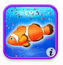 | Baby Aquarium (.99) | 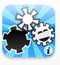 | BrightStart Babies (free)
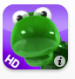 | Balloonimals (2.99) |  | I Love Fireworks Lite (.99)

ABA - DISCRETE TRIAL TRAINING (DTT)
 | ABA Receptive Identification (.99) | 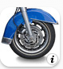 | ABA Recetive Identification –  by Function (.99)
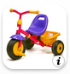 | ABA Receptive Identification –  by Feature (.99) | 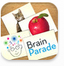 | See Touch Learn (free)

JUST FOR FUN/SPECIAL INTERESTS
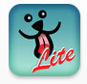 | Clean my Screen Lite (free) | 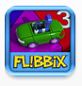 | Flibbix Spinner
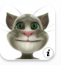 | Talking Tom Cat (free) | 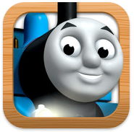 | Thomas and Friends: Engine Activities (free)
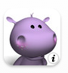 | Talking Baby Hippo (2.99) | 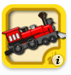 | Clicky Sticky Trains (1.99)

iOS Tips for Toddlers
- Provide children with an abundance of opportunities to learn concepts through sensory experiences, movement and by exploring toys, objects, materials and their environment. Technology should NEVER totally replace opportunities for active engagement unless the child is unable to explore on their own because of his/her disability.
- Some children are especially engaged with iOS devices because apps are visually engaging and feature music and novel experiences. Other children appreciate apps because the activities are predictable and consistent.
- Select apps that feature the child’s area of interest (trains, animals, coloring, etc.).
- Create opportunities for children to play with the iPad beside or with other children.
- Limit the amount of time young children are allowed to play with iPads to short periods of time (10-15 minutes at a time). Play together with your child to teach joint attention, expressive and receptive language, literacy and numeracy concepts, social skills and other needed skills.
- When using iOS devices for the purpose of assistive technology, consider the child’s need for assistive technology by looking at the child’s skills and needs, the demands of the environment, tasks to be accomplished and other tools available. Begin with low-tech solutions (such as object and picture schedules, simple AAC devices, etc.). If a child is more proficient using a low- tech system, than an iOS device, then the low-tech system is the preferred system. (Don’t be fooled by the excitement of new technology)
- When using iOS devices for AAC with very young children, assess the child’s receptive understanding of words, understanding of two-dimensional picture representation, ability to choose between multiple pictures presented, size of pictures needed as well as portability and accessibility of the device.
- Personalize your child’s stories and favorite apps with familiar pictures (such as favorite toys, family members, friends, etc.). Teach skills through social stories.
- Since iOS devices are so portable and accessible, remember to protect your device with protective cases.

iPAD ACCESSORIES
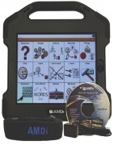 | iAdapter Case, ($198), www.aacink.com  – rubberized case, hides home button, built in speakers
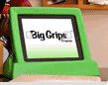 | Big Grip iPad Case, www.biggrips.com, rubberized, easy to grip
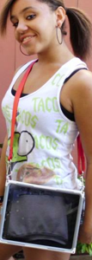 | RJ Cooper iPad Carrying Case ($79), www.rjcooper.com
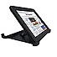 | Otterbox Defender ($29.95-$89.95), www.otterbox.com
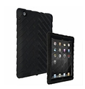 | GumDrop Drop Tech Series Case ($59), www.gumdropcases.com
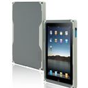 | Incipio Destroyer ($19.99-$75.99), www.incipio.com
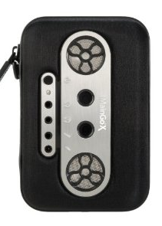 | iMaingoX –speaker case ($59.95), www.amazon.com
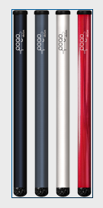 | Pogo Pointer (14.95), www.amazon.com

IDEA: If a child drags their hand across the screen, have the child wear a knit glove with the tip of the finger cut out for the activation point. This will help prevent unwanted selections.

Helpful Resources – Just a Few….
Autism Spectrum Directory
http://blog.autismspectrumdirectory.com/2011/01/23/ipad-ipod-touch-and-iphone-apps-learning-games-for-applied-behavioral-analysis-aba/
Moms with Apps - Check-out AppFriday!!, http://momswithapps.com/
Apps and Autism – http://www.ipodsibilities.com
Apps for Autism – http://174.122.132.2/~hubsmom/
Apps for Children with Special Needs – http://a4cwsn.com
Autism Apps – Nice resource for apps divided by area of use https://autismapps.wikispaces.com
SLP Sharing by Eric Sailers – http://slpsharing.com/
Mobile learning 4 Special Needs – http://mobilelearning4specialneeds.wikispaces.com/Apps
Education Apps Review -http://www.iear.org/
Top 4 best iPad apps, games - http://ipad.blorge.com/2010/04/03/top-40-best-ipad-apps.games/
Best Kids Apps – Preschool Apps – http://bestappsforkids.com/category/apps-by-age-grade/preschool-apps/
Apps for Special Education by Paula Walser – http://maximizeyourtouch.pbworks.com/w/page/30796448/FrontPage

S. Jones, VDOE T/TAC at VCU
Revised 3/12

