THE USE OF IPADS IN EARLY CHILDHOOD

LITERACY
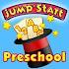 | JumpStart Preschool Magic of Learning ($2.99) | 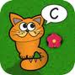 | Sound Seeker ($1.99)
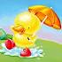 | One Rainy Day ($3.99 for iPad or $1.99 for iPhone) | 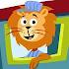 | Zoo Train ($1.99)
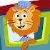 | Zoo Train ($1.99) | 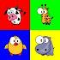 | ABC Phonics (Free)
 | Monkey Preschool Lunchbox ($0.99) | 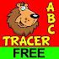 | ABC Tracer (Free or $1.99)
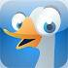 | ABC Animals ($1.99) | 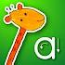 | iWriteWords (Free or $2.99)
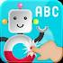 | Interactive Alphabet ($2.99)

PRINT AND BOOK AWARENESS
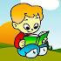 | Story Time for Kids (Free) | 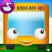 | Wheels on the Bus HD  ($1.99 for iPad or $0.99 for iPhone)
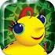 | Miss Spider’s Tea Party  ($2.99 for iPad or $1.99 for iPhone) | 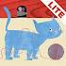 | A Present for Milo (Free or $3.99)
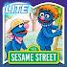 | Grover’s Farm (Free) | 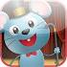 | Speech with Milo ($2.99)

eBOOKS
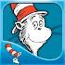 | Cat In the Hat ($2.99) | 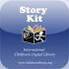 | Story Kit (Free)
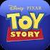 | Toy Story (Free) | 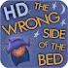 | 3D Story Book ($2.99)
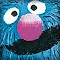 | The Monster at the End of This book ($3.99)

PRE-WRITING
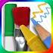 | Drawing Pad ($1.99) | 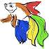 | Kid Finger Painting (Free)
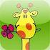 | Kid Art ($0.99) | 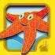 | Clicky Sticky ($1.99)

MATH
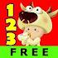 | 123 Animals Count (Free) | 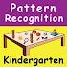 | Kindergarten Pattern Recognition ($0.99)
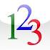 | Toddler Counting ($0.99) | 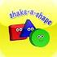 | Shake-a-Shape ($0.99)
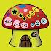 | Basic Sequencing Skills ($0.99) | 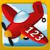 | Tally Tots ($1.99)
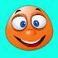 | Learning Pad ($1.99) |  | Toddler Email ($0.99)

SCIENCE
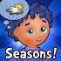 | i Learn with Poko: Seasons and Weather! HD ($2.99) | 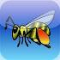 | Seed Cycle ($0.99)

MUSIC
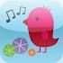 | Sound Shaker ($.1.99) | 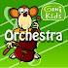 | Genikids Orchestra ($1.99)
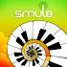 | Magic Piano ($1.99) | 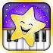 | Twinkle Twinkle Little Star ($1.99)

SOCIAL-EMOTIONAL DEVELOPMENT
 | Stories2Learn ($13.99) |  | iReward ($4.99)
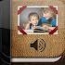 | Pictello ($18.99) | 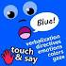 | Touch & Say (Free)
 | Model Me Going Places (Free) | 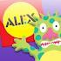 | Moody Monsters (Free)

MAKING CHOICES
 | My Choice Board ($9.99) | 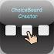 | ChoiceBoard-Creator (Free)

Helpful Links
- Education Apps Review: http://www.iear.org/
- IEAR App Review: http://spreadsheets.google.com/pub?key=tt_JWM-axijCp-2EfTBtSxg&single=true&gid=0&output=html
- Top 50 Free Education Apps: http://www.appstoreapps.com/top-50-free-education-apps/
- Top 40 best iPad apps, games: http://ipad.blorge.com/2010/04/03/top-40-best-ipad-apps-games/
- AppSmile - Best iPad Apps: http://www.appsmile.com/best-ipad-apps/
- iPad Apptitude : http://www.autismepicenter.com/autism-blog/blog5.php
- Apps for Special Education by Paula Walser : http://maximizeyourtouch.pbworks.com/w/page/30796448/FrontPage
- Best iPad Apps for Autism and Asperger’s Syndrome: http://www.bookroomreviews.com/2010/08/16/best-ipad-apps-for-autism-and-aspergers-syndrome/
- iKidApps – Best Free Math Apps : http://www.ikidapps.com/2011/04/best-free-math-apps.html
- Kids-apps.mobi: http://kids-apps.mobi/
- Smart Apps for Kids: http://www.smartappsforkids.com/
- Best Kids Apps: http://www.bestkidsapps.com/
- Best Kids Apps – Preschool Apps: http://bestappsforkids.com/category/apps-by-age-grade/preschool-apps/
- Fun Educational Apps: http://www.funeducationalapps.com/apps-for-toddlers-and-preschoolers/
- Special Education Apps: http://www.ipodsibilities.com/iPodsibilities/SpEd_Apps.html
- iOS School http://sites.google.com/site/iosschoolwide/

