Free Tools & Resources

**Milestones Brochures** – sample milestones, importance of early action, how to find help, Spanish available separately

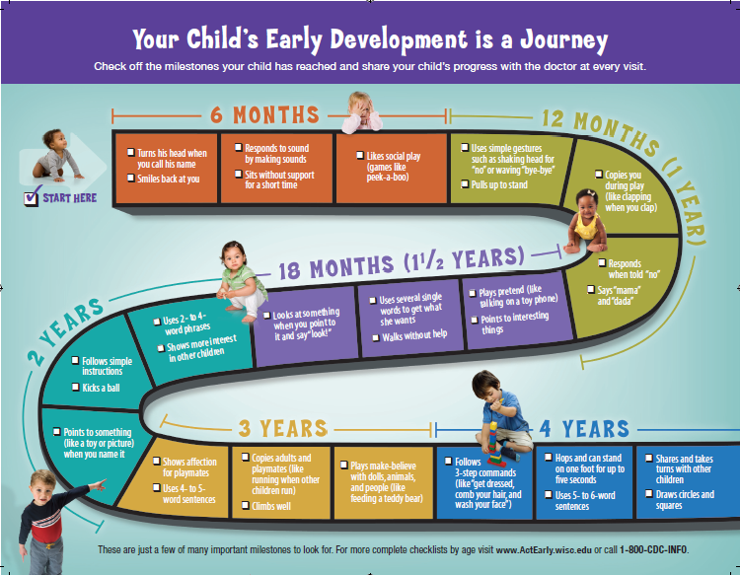

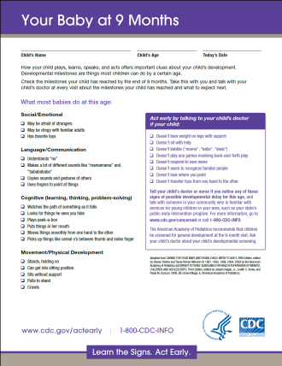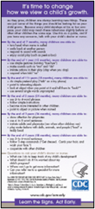

**Milestones Checklists** – one page complete checklists for each age (2m- 5y), signs it’s time to act early, how to find help, when to expect screening, Spanish on back

**Milestones Card** – sample milestones, questions to ask child’s doctor, Spanish on back